Analyze
To analyze is to look at closely.

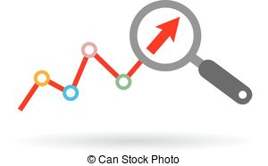Data

Data is the information we collect from an experiment.

Pattern
A pattern is something we notice happens again, something that repeats.

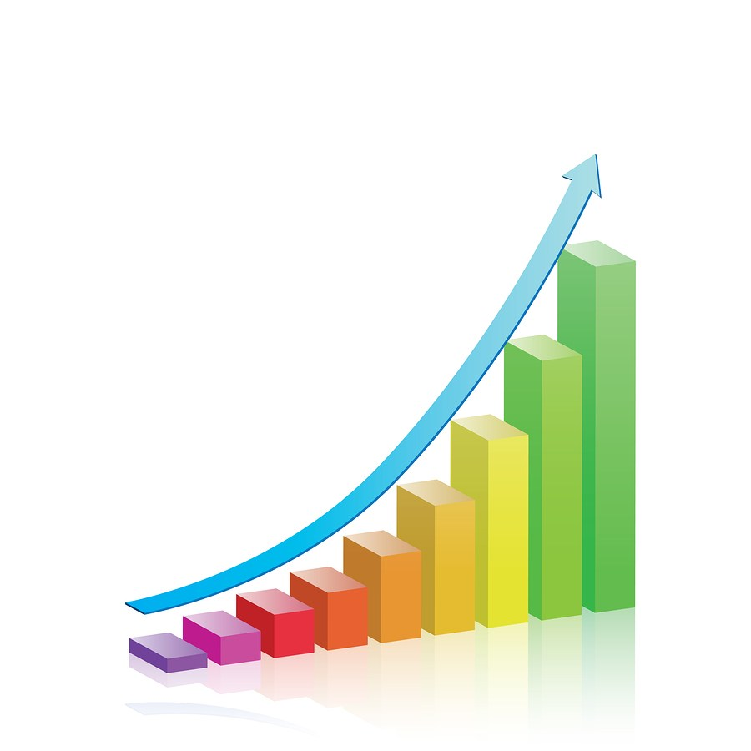Trend
The general direction of
how something is changing.

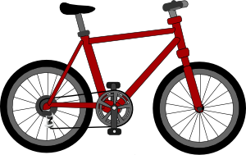System
A system is a set of
connected things that work
together, or parts that form a whole.

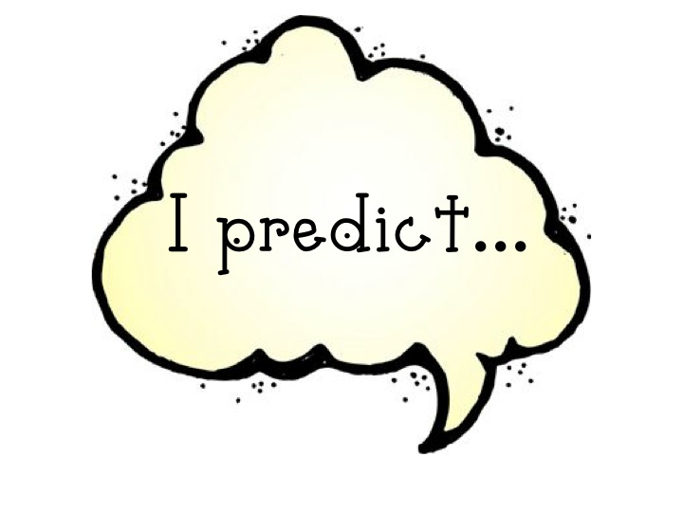Prediction
A statement about what
we think will happen or
might happen in the future

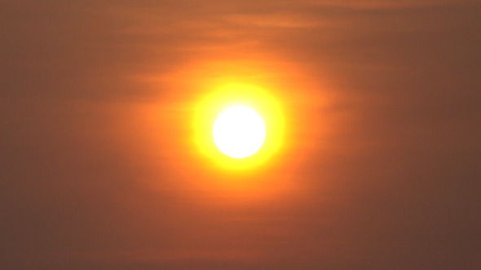

The Sun

Class Data

Day: | Morning | Lunch | Afternoon
Shadow Direction
Shadow Length
Shadow Darkness

Day: | Morning | Lunch | Afternoon
Shadow Direction
Shadow Length
Shadow Darkness

Day: | Morning | Lunch | Afternoon
Shadow Direction
Shadow Length
Shadow Darkness
Sun Location

Day: | Morning | Lunch | Afternoon
Shadow Direction
Shadow Length
Shadow Darkness
Sun Location
Class Data – Example Key

Day: 1 | Morning | Lunch | Afternoon
Shadow Direction | West | North | East
Shadow Length | Long | Short | Long
Shadow Darkness | Dark | Dark | Dark

Day: 2 | Morning | Lunch | Afternoon
Shadow Direction | West | North | East
Shadow Length | Long | Short | Long
Shadow Darkness | Dark | Dark | Dark

Day: 3 | Morning | Lunch | Afternoon
Shadow Direction | West | North | East
Shadow Length | Long | Short | Long
Shadow Darkness | Dark | Dark | Dark
Sun Location | East and low | North and high | West and low

Day: 4 | Morning | Lunch | Afternoon
Shadow Direction | West | North | East
Shadow Length | Long | Short | Long
Shadow Darkness | Dark | Dark | Dark
Sun Location | East and low | North and high | West and low

