Name:________________

Directions: Look closely at the two pictures below. How are they different? Both landforms resulted from the erosion of earth materials by running water. Discuss with a partner what factors might have caused the differences you observe.

A valley A canyon
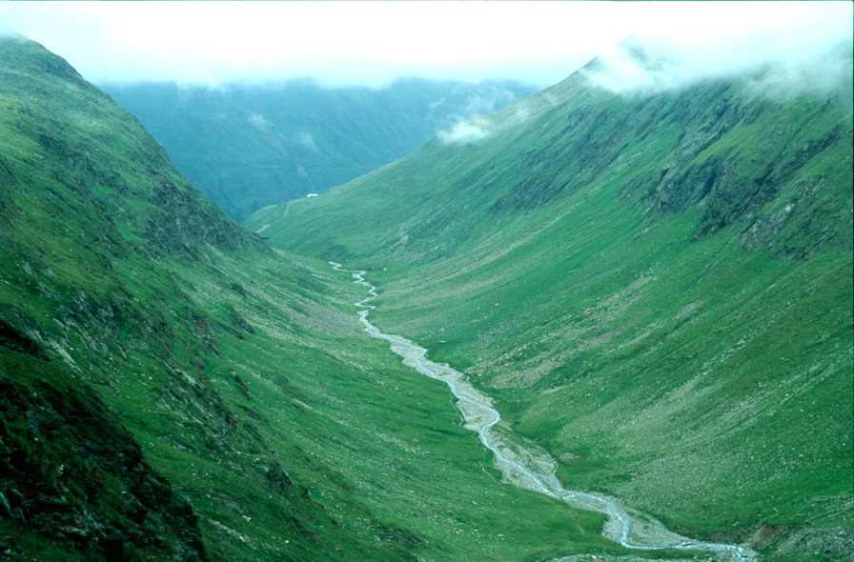 | 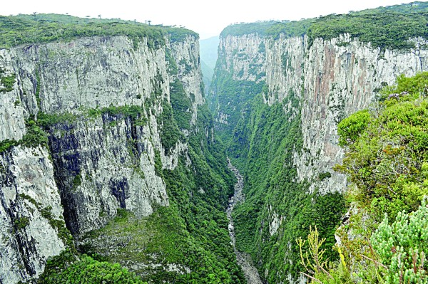

Focus Question: What variables affect the erosion of earth materials in a stream table?

Variables we think might affect the erosion of earth materials (e.m.) in a stream table. Explain your thinking.

1.__________________________________________________________
2.__________________________________________________________
3.__________________________________________________________
4.__________________________________________________________
5. _________________________________________________________

QUESTION: If we change the stream table elevation or amount of water, what
(Circle one of the above variables)

will happen to _________________________________________________________________?

Experimental Set-Up
You may select 3 values from the list below. Determine the values of your changing variable and write the values for your three trials.

1. Stream Table Elevation Values: ½ in., 1 in., 1½in., 2 in., 2½, 3 in.
Water Quantity – 100 mL for all values

2. Water Quantity Values: 100 mL, 200 mL, 300 mL, 400 mL, 500 mL, 600 mL
Elevation – ¼” for all values

Changing Variable: Trial A Trial B Trial C
What you circled above

Controls: Variables that will not be changed

_______________________________/____________________________

_______________________________/____________________________

_______________________________/____________________________

_______________________________/____________________________

Prediction: We predict the earth material will move the farthest in Trial __

because ____________________________________________________

Investigation Procedure:

1.__________________________________________________________

___________________________________________________________

2.__________________________________________________________

___________________________________________________________

3.__________________________________________________________

___________________________________________________________

4.__________________________________________________________

___________________________________________________________

5.__________________________________________________________

___________________________________________________________

Results Data:
Stream Table Observations:
Changing Variable: _____________________________________________________
Trial A: Changing Variable Value ___________________________________________
Trial B: Changing Variable Value ___________________________________________
Trial C: Changing Variable Value ___________________________________________

Results Data:
Distance the Earth Materials Moved (cm)
Trial A Trial B Trial C
________________
Changing Variable
Distance
Moved (cm)

Conclusion: (A claim supported by data)

The result of the experiment shows ______________________________
^{Claim}
___________________________________________________________

___________________________________________________________

because____________________________________________________
^{Data (measurement/observation)}

____________________________________________________________

____________________________________________________________

____________________________________________________________

Discussion Questions:
1. What effect did the water amount have on erosion? Why?

2. What effect did the steeper slope have on erosion? Why?

3. How do erosion factors affect landforms?
Refer back to the canyon and valley landform pictures. Based upon your investigation, predict which of these 2 landforms would most likely result.

- A stream running down a small, low-sloped hill over time will likely
cause a _________________________.
Explain your reasoning.

________________________________________________________________________________________

_______________________________________________________________________________________

_______________________________________________________________________________________

_______________________________________________________________________________________

- A stream running down a tall, steep mountain overtime will likely
cause a ________________________________ .
Explain your reasoning.

________________________________________________________________________________________

_______________________________________________________________________________________

_______________________________________________________________________________________

_______________________________________________________________________________________

_______________________________________________________________________________________

