Name:

My Weather Patterns Journal Monday

Look at the pictures and videos of weather.
As a class, go outside and observe the weather.

Directions: Circle the clothes you should wear today.

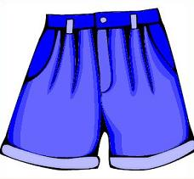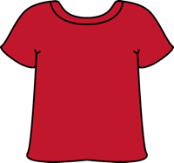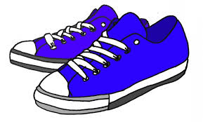

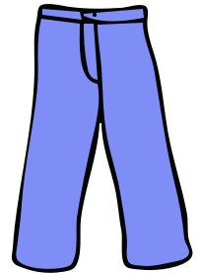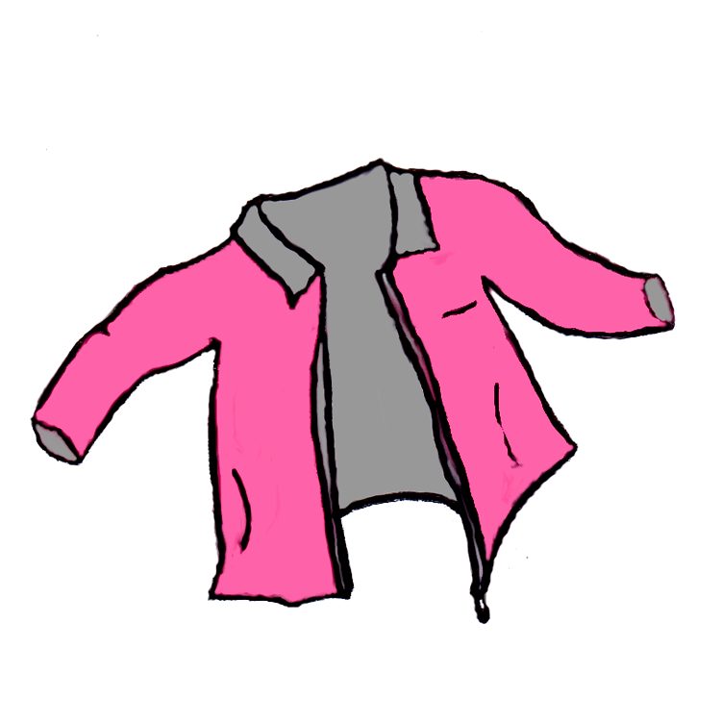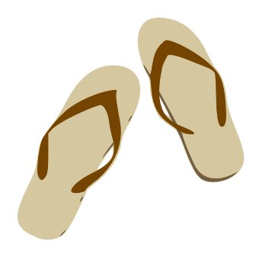
What is the weather like today?
Word Bank:
sunny cloudy foggy rainy stormy
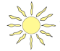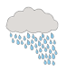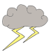
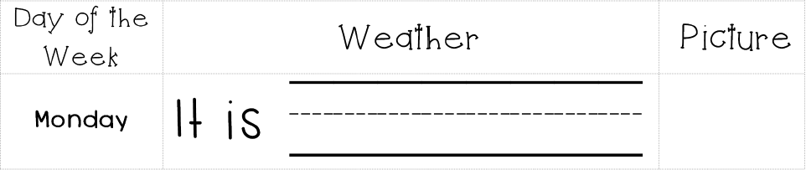

My Weather Patterns Journal Tuesday

Directions: Circle the clothes you should wear today.

What is the weather like today?
Word Bank:
sunny cloudy foggy rainy stormy

Tomorrow I think it will be .

My Weather Patterns Journal Wednesday

Directions: Circle the clothes you should wear today.

What is the weather like today?
Word Bank:
sunny cloudy foggy rainy stormy

Tomorrow I think it will be .

My Weather Patterns Journal Thursday

Directions: Circle the clothes you should wear today.

What is the weather like today?
Word Bank:
sunny cloudy foggy rainy stormy

Tomorrow I think it will be .

My Weather Patterns Journal Friday

Directions: Circle the clothes you should wear today.

What is the weather like today?
Word Bank:
sunny cloudy foggy rainy stormy

Tomorrow I think it will be .

My Weather Patterns Journal Weekly Reflection

Directions: Write the number of days for each type of weather.
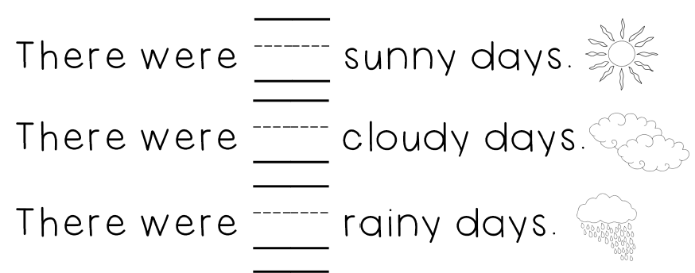
Directions: Circle the type of weather that happened most.
Word Bank:
sunny cloudy foggy rainy stormy

Next week I think it will be .

My Weather Patterns Journal Weekly Reflection

PARTNER TALK: 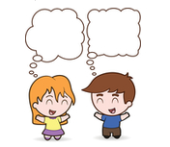

“This week was _______________________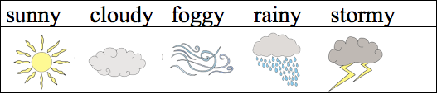
the most because it was__________________
for ________ days.”

My Weather Patterns Journal End of the Month Reflection

DATA: At the end of the month:
This month had the most amount of (circle one):

Discussion Questions:

1. What type of weather happened the most this month?

2. What type of weather happened the least this month?

Prediction: What do you think we will have the most days next month?

My Weather Patterns Journal Big Bear, California Reflection

Look at data from kindergarten class in Big Bear, California.

DATA: At the end of the month:
This month had the most amount of (circle one):
Word Bank:
sunny cloudy foggy rainy stormy snowy
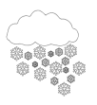
Discussion Questions:

1. What type of weather happened the most this month?

2. What type of weather happened the least this month?

3. Is Big Bear, California’s weather the same or different from our weather?
Big Bear has the (same/different) __________

type of weather because_________________.

